I purchased both these medicines from Netmeds.com

1). I purchased this **GKD2176B** in 2023 and here there shelf life of medicine is **17 months**

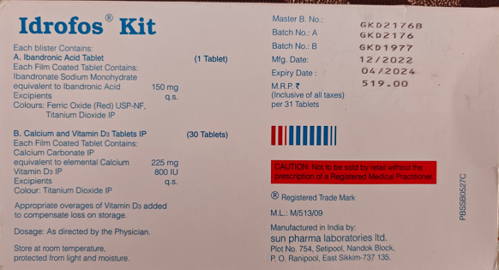

2). I purchased this **GKF1146A** in December 2024 and here the shelf life of medicine is only **13 months, why?** I can’t see any change in the formulation of the medicne as per the details available then how the shelf life of medicine is reduced by 4 months.

