SUN pharmaceuticals quality report

Problem: Vials found missing lot & exp from the label.

Lot & Exp (obtained from outside box package): BAD0303A & 07/2025

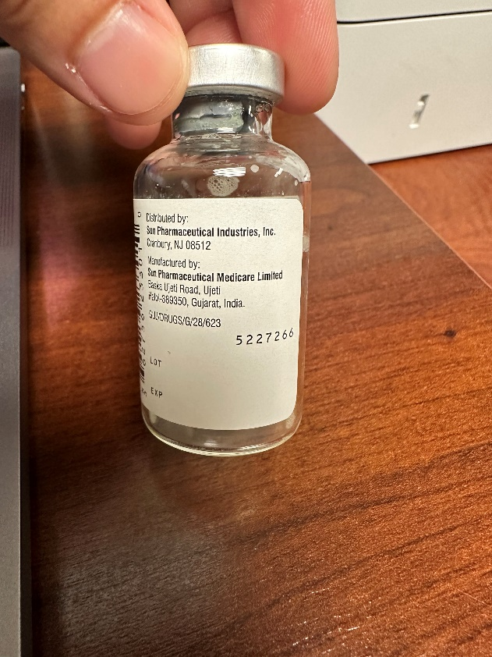 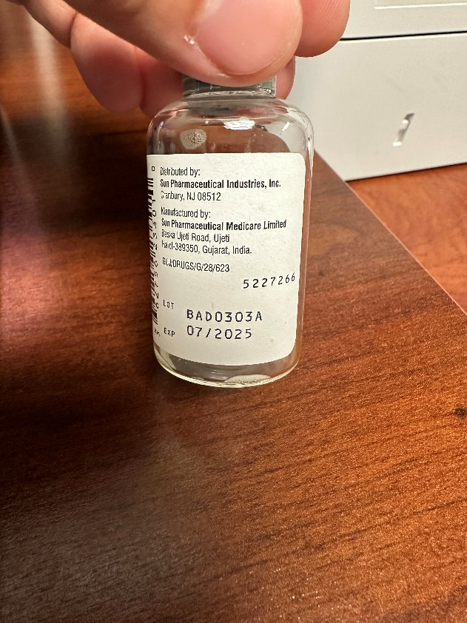

Reported 01/11/23